Coronavirus disease 2019 (COVID-19)
Situation Report – 72

Data as reported by national authorities by 10:00 CET 1 April 2020

HIGHLIGHTS
- Three new countries/territories/areas reported cases of COVID-19 in the past 24 hours: Botswana, Burundi, and Sierra Leone.

- WHO has released a scientific brief on the off-label use of medicines for COVID-19. A number of medicines have been suggested as potential investigational therapies, many of which are now being or will soon be studied in clinical trials, including the SOLIDARITY trial co-sponsored by WHO and participating countries. More information can be found here.

- WHO recognizes the importance of addressing the needs of refugees and migrants when preparing for or responding to the COVID-19 pandemic. WHO European Region has released a guidance document to assist healthcare working with refugees and migrants. More information can be found here.

- At a press briefing, yesterday, PAHO Director Dr. Carissa Etienne stressed that countries of the Americas must act now to slow the spread of COVID-19. WHO encourages countries to prepare hospitals and health facilities, protect their health personnel, and decide what social distancing measures need to be implemented and for how long, among other actions. Find more here.

- Public health and social measures to slow or stop the spread of COVID-19 must be implemented with the full engagement of all members of society. WHO has described four levels of COVID-19 transmission with varying public health and social measures depending on the local evolution of the COVID-19 pandemic. For more details, please see ‘Subject in Focus’.
SITUATION IN NUMBERS
total (new) cases in last 24 hours

Globally
823 626 confirmed (72 736)
40 598 deaths (4193)
Western Pacific Region
106 422 confirmed (1554)
3701 deaths (30)

European Region
464 212 confirmed (40 266)
30 089 deaths (3395)

South-East Asia Region
5175 confirmed (960)
195 deaths (29)

Eastern Mediterranean Region
54 281 confirmed (3932)
3115 deaths (161)

Region of the Americas
188 751 confirmed (25 737)
3400 deaths (564)

African Region
4073 confirmed (287)
91 deaths (14)

WHO RISK ASSESSMENT
Global Level Very High

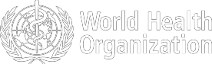
Figure 1. Countries, territories or areas with reported confirmed cases of COVID-19, 1 April 2020

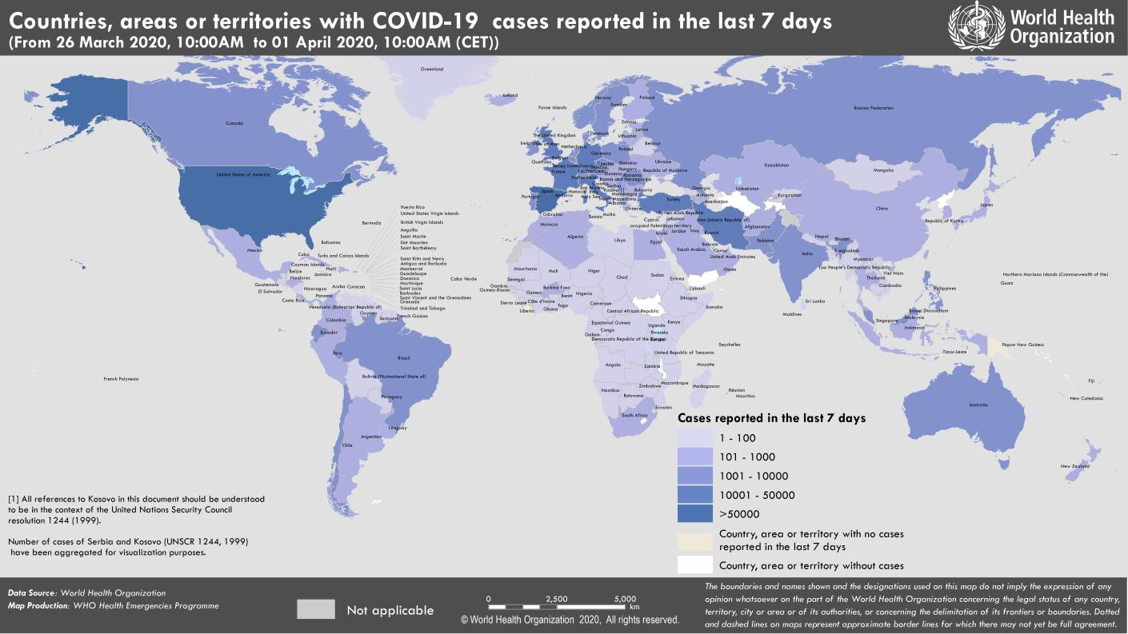

SUBJECT IN FOCUS: Public Health and Social Measures for the COVID-19 Pandemic

The purpose of this note is to outline public health and social measures useful for slowing or stopping the spread of COVID-19 at national or community level. Guidance for case finding and management, personal and environmental measures, travel measures, and mass gatherings is available on the WHO website available here.

Public health and social measures are measures or actions by individuals, institutions, communities, local and national governments and international bodies to slow or stop the spread of COVID-19. These measures to reduce transmission of COVID-19 include individual and environmental measures, detecting and isolating cases, contact- tracing and quarantine, social and physical distancing measures including for mass gatherings, international travel measures, and vaccines and treatments. While vaccines and specific medications are not yet available for COVID-19, other public health and social measures play an essential role in reducing the number of infections and saving lives.

Social and physical distancing measures aim to slow the spread of disease by stopping chains of transmission of COVID-19 and preventing new ones from appearing. These measures secure physical distance between people (of at least one metre), and reduce contact with contaminated surfaces, while encouraging and sustaining virtual social connection within families and communities. Measures for the general public include introducing flexible work arrangements such as teleworking, distance learning, reducing and avoiding crowding, closure of non-essential facilities and services, shielding and protection for vulnerable groups, local or national movement restrictions and staying-at home measures, and coordinated reorganization of health care and social services networks to protect hospitals. The measures are used in conjunction with individual protective measures against COVID-19 such as frequent hand washing and cough etiquette.

All public health measures to stop disease spread can be balanced with adaptive strategies to encourage community resilience and social connection, protect incomes and secure the food supply. Countries should balance the possible benefits and negative consequences of each intervention and deploy strategies to encourage community engagement, gain trust and limit social or economic harm. There are many strategies that can support community resilience and mental health, protect access to essential goods and services, and limit the economic impact of stay- at-home measures where these are deemed necessary. For example, organizing work-sites to ensure physical distance between persons, such as staggering shifts over time, or converting on-site service to home delivery may help to keep more businesses open. Tele-working and tele-schooling strategies in different contexts demonstrate innovation and the role of technology in supporting business continuity and sustaining social connection within families and communities. In general, implementation of distancing measures should also aim to sustain personal and professional community connections by virtual means and technology, including widely accessible means such as radio and mobile phones.

Alongside all these measures remains there is the critical to test all suspected cases of COVID-19 wherever possible, promptly isolate cases, trace contacts to the widest extent possible, and ensure quarantine of contacts for the duration of the incubation period. This goes for any context or level of spread of the pandemic in a country, in order to deepen the benefits of social measures. Social measures should make the task of contact tracing much easier as the number of contacts rapidly dwindles and eventually the number of cases declines as well. As social measures are lifted, it is essential to continue to strengthen case-finding, isolation for COVID-19 cases and quarantine of contacts, in order to respond to resurgent or imported cases. Coordinated reorganization of health and social services is essential to assess and test persons rapidly, treat patients effectively, and protect hospitals and health personnel.

WHO has described four levels of COVID-19 transmission. These are countries or local areas with: 1. No cases reported. 2. Sporadic cases. 3. Clusters of cases (grouped in place and time), or 4. Community transmission. Countries are putting in place a range of public health and social measures in different combinations and at varying times in the local evolution of the COVID-19 pandemic. The alignment of public health measures to levels of transmission in a community is not fixed in stone. Countries may wish to specify which measures are to be taken at each level and review the situation regularly. A package of measures may be applied at local, regional or national level and adjusted as needed, considering aspects such as culture, living environments, terrain and access to needed resources. Essential services should remain operational and governments should put in place social and economic policies to limit the longer term economic impact, support community resilience and enable rapid recovery. Most importantly, the ultimate aim is to ‘walk back’ community transmission to clusters, sporadic cases, and down to no cases at all, and to begin gradually lifting social measures as soon as it is safe to do so. Guidance for lifting measures
is being developed.

To be effective, public health measures must be implemented with the full engagement of all members of society, including communities and professional groups. All measures should be accompanied with clear, accessible and regular risk communication to explain the response strategy and enable people to make informed decisions to protect themselves and help achieve the public health goal of ending the outbreak.

A table summarizing public health and social measures to support control of COVID-19 will be available shortly at www.who.int/epi-win.
SURVEILLANCE

Table 1. Countries, territories or areas with reported laboratory-confirmed COVID-19 cases and deaths. Data as of 1 April 2020*
Reporting Country/ Territory/Area† | Total confirmed  ‡ cases |  | Total confirmed new cases | Total deaths | Total new deaths | Transmission classification§ | Days since last reported case
Western Pacific Region
China |  | 82631 | 86 | 3321 | 7 | Local transmission | 0
Republic of Korea |  | 9887 | 101 | 165 | 3 | Local transmission | 0
Australia |  | 4707 | 348 | 20 | 2 | Local transmission | 0
Malaysia |  | 2766 | 140 | 43 | 6 | Local transmission | 0
Japan |  | 2178 | 225 | 57 | 1 | Local transmission | 0
Philippines |  | 2084 | 538 | 88 | 10 | Local transmission | 0
Singapore |  | 926 | 47 | 3 | 0 | Local transmission | 0
New Zealand |  | 647 | 47 | 1 | 0 | Local transmission | 0
Viet Nam |  | 207 | 4 | 0 | 0 | Local transmission | 0
Brunei Darussalam |  | 129 | 2 | 1 | 0 | Local transmission | 0
Cambodia |  | 109 | 2 | 0 | 0 | Local transmission | 0
Mongolia |  | 12 | 0 | 0 | 0 | Imported cases only | 4
Lao People's Democratic Republic |  | 9 | 1 | 0 | 0 | Local transmission | 0
Fiji |  | 5 | 0 | 0 | 0 | Local transmission | 6
Papua New Guinea |  | 1 | 0 | 0 | 0 | Imported cases only | 11
Territories**
Guam |  | 69 | 11 | 2 | 1 | Local transmission | 0
French Polynesia |  | 37 | 1 | 0 | 0 | Local transmission | 0
New Caledonia |  | 16 | 1 | 0 | 0 | Local transmission | 0
Northern Mariana Islands (Commonwealth of the) |  | 2 | 0 | 0 | 0 | Under investigation | 3
European Region
Italy |  | 105792 | 4053 | 12430 | 839 | Local transmission | 0
Spain |  | 94417 | 9222 | 8189 | 849 | Local transmission | 0
Germany |  | 67366 | 5453 | 732 | 149 | Local transmission | 0
France |  | 51477 | 7500 | 3514 | 497 | Local transmission | 0
The United Kingdom |  | 25154 | 3009 | 1789 | 381 | Local transmission | 0
Switzerland |  | 16108 | 696 | 373 | 78 | Local transmission | 0
Turkey |  | 13531 | 2704 | 214 | 46 | Local transmission | 0
Belgium |  | 12775 | 876 | 705 | 192 | Local transmission | 0
Netherlands |  | 12595 | 845 | 1039 | 175 | Local transmission | 0
Austria |  | 10182 | 564 | 128 | 20 | Local transmission | 0
Portugal |  | 7443 | 1035 | 160 | 20 | Local transmission | 0
Israel |  | 5129 | 298 | 21 | 4 | Local transmission | 0
Norway |  | 4447 | 221 | 28 | 2 | Local transmission | 0
Sweden |  | 4435 | 407 | 180 | 34 | Local transmission | 0
Czechia |  | 3308 | 306 | 31 | 7 | Local transmission | 0

Ireland | 3235 | 325 | 71 | 17 | Local transmission | 0
Denmark | 2860 | 283 | 90 | 13 | Local transmission | 0
Russian Federation | 2337 | 500 | 17 | 8 | Local transmission | 0
Poland | 2311 | 256 | 33 | 2 | Local transmission | 0
Romania | 2245 | 293 | 69 | 25 | Local transmission | 0
Luxembourg | 2178 | 190 | 23 | 1 | Local transmission | 0
Finland | 1384 | 71 | 17 | 4 | Local transmission | 0
Greece | 1314 | 102 | 49 | 6 | Local transmission | 0
Iceland | 1135 | 49 | 2 | 0 | Local transmission | 0
Serbia | 900 | 115 | 13 | 0 | Local transmission | 0
Croatia | 867 | 77 | 6 | 0 | Local transmission | 0
Slovenia | 814 | 51 | 13 | 2 | Local transmission | 0
Estonia | 745 | 30 | 4 | 1 | Local transmission | 0
Ukraine | 669 | 120 | 17 | 4 | Local transmission | 0
Lithuania | 533 | 49 | 7 | 0 | Local transmission | 0
Armenia | 532 | 50 | 3 | 0 | Local transmission | 0
Hungary | 492 | 45 | 16 | 1 | Local transmission | 0
Bosnia and Herzegovina | 413 | 54 | 12 | 3 | Local transmission | 0
Bulgaria | 399 | 40 | 8 | 0 | Local transmission | 0
Latvia | 398 | 22 | 0 | 0 | Local transmission | 0
Andorra | 376 | 6 | 12 | 4 | Local transmission | 0
Slovakia | 363 | 27 | 0 | 0 | Local transmission | 0
Republic of Moldova | 353 | 55 | 3 | 1 | Local transmission | 0
Kazakhstan | 348 | 36 | 2 | 1 | Local transmission | 0
North Macedonia | 329 | 44 | 9 | 2 | Local transmission | 0
Azerbaijan | 298 | 25 | 5 | 1 | Local transmission | 0
Cyprus | 262 | 32 | 8 | 1 | Local transmission | 0
Albania | 243 | 20 | 13 | 2 | Local transmission | 0
San Marino | 236 | 6 | 26 | 1 | Local transmission | 0
Uzbekistan | 173 | 24 | 2 | 0 | Local transmission | 0
Malta | 167 | 11 | 0 | 0 | Local transmission | 0
Belarus | 152 | 0 | 0 | 0 | Local transmission | 2
Georgia | 115 | 12 | 0 | 0 | Local transmission | 0
Kyrgyzstan | 111 | 4 | 0 | 0 | Local transmission | 0
Montenegro | 105 | 14 | 2 | 1 | Local transmission | 0
Liechtenstein | 68 | 4 | 0 | 0 | Under investigation | 0
Monaco | 52 | 3 | 0 | 0 | Local transmission | 0
Holy See | 6 | 0 | 0 | 0 | Under investigation | 2
Territories**
Faroe Islands | 169 | 1 | 0 | 0 | Local transmission | 0
Kosovo[1] | 112 | 6 | 1 | 0 | Local transmission | 0
Gibraltar | 69 | 0 | 0 | 0 | Local transmission | 1
Jersey | 63 | 0 | 2 | 0 | Local transmission | 2
Guernsey | 60 | 15 | 1 | 1 | Local transmission | 0
Isle of Man | 52 | 10 | 0 | 0 | Local transmission | 0
Greenland | 10 | 0 | 0 | 0 | Under investigation | 3
South-East Asia Region
Thailand | 1771 | 247 | 12 | 3 | Local transmission | 0
India | 1636 | 565 | 38 | 9 | Local transmission | 0

Indonesia | 1528 | 114 | 136 | 14 | Local transmission | 0
Sri Lanka | 143 | 23 | 2 | 1 | Local transmission | 0
Bangladesh | 54 | 5 | 6 | 1 | Local transmission | 0
Maldives | 18 | 1 | 0 | 0 | Local transmission | 0
Myanmar | 15 | 5 | 1 | 1 | Local transmission | 0
Nepal | 5 | 0 | 0 | 0 | Imported cases only | 3
Bhutan | 4 | 0 | 0 | 0 | Imported cases only | 2
Timor-Leste | 1 | 0 | 0 | 0 | Under investigation | 11
Eastern Mediterranean Region
Iran (Islamic Republic of) | 44606 | 3111 | 2898 | 141 | Local transmission | 0
Pakistan | 2039 | 174 | 26 | 1 | Local transmission | 0
Saudi Arabia | 1563 | 110 | 10 | 2 | Local transmission | 0
Qatar | 781 | 88 | 2 | 1 | Local transmission | 0
Egypt | 710 | 54 | 46 | 5 | Local transmission | 0
Iraq | 694 | 64 | 50 | 4 | Local transmission | 0
United Arab Emirates | 664 | 53 | 6 | 1 | Local transmission | 0
Morocco | 638 | 64 | 36 | 3 | Local transmission | 0
Bahrain | 567 | 52 | 4 | 0 | Local transmission | 0
Lebanon | 463 | 17 | 12 | 1 | Local transmission | 0
Tunisia | 394 | 32 | 10 | 1 | Local transmission | 0
Kuwait | 289 | 23 | 0 | 0 | Local transmission | 0
Jordan | 274 | 6 | 5 | 0 | Local transmission | 0
Oman | 210 | 31 | 1 | 1 | Local transmission | 0
Afghanistan | 192 | 26 | 4 | 0 | Local transmission | 0
Djibouti | 31 | 5 | 0 | 0 | Local transmission | 0
Libya | 10 | 2 | 0 | 0 | Local transmission | 0
Syrian Arab Republic | 10 | 0 | 2 | 0 | Imported cases only | 1
Sudan | 7 | 1 | 2 | 0 | Imported cases only | 0
Somalia | 5 | 2 | 0 | 0 | Imported cases only | 0
Territories**
occupied Palestinian territory | 134 | 17 | 1 | 0 | Local transmission | 0
Region of the Americas
United States of America | 163199 | 22559 | 2850 | 452 | Local transmission | 0
Canada | 7695 | 1378 | 89 | 23 | Local transmission | 0
Brazil | 4579 | 323 | 159 | 23 | Local transmission | 0
Chile | 2738 | 289 | 12 | 4 | Local transmission | 0
Ecuador | 2240 | 278 | 75 | 15 | Local transmission | 0
Dominican Republic | 1109 | 208 | 51 | 9 | Local transmission | 0
Mexico | 1094 | 101 | 28 | 8 | Local transmission | 0
Peru | 1065 | 213 | 24 | 13 | Local transmission | 0
Panama | 989 | 0 | 24 | 0 | Local transmission | 1
Argentina | 966 | 146 | 24 | 4 | Local transmission | 0
Colombia | 798 | 96 | 14 | 4 | Local transmission | 0
Uruguay | 320 | 11 | 1 | 1 | Local transmission | 0
Costa Rica | 314 | 0 | 2 | 0 | Local transmission | 1
Cuba | 186 | 16 | 6 | 2 | Local transmission | 0
Honduras | 139 | 0 | 2 | 0 | Local transmission | 1

Venezuela (Bolivarian Republic of) | 129 | 0 | 3 | 0 | Local transmission | 1
Bolivia (Plurinational State of) | 107 | 10 | 6 | 1 | Local transmission | 0
Trinidad and Tobago | 85 | 3 | 3 | 0 | Local transmission | 0
Paraguay | 65 | 1 | 3 | 0 | Local transmission | 0
Guatemala | 36 | 0 | 1 | 0 | Local transmission | 1
Jamaica | 36 | 0 | 1 | 0 | Local transmission | 1
Barbados | 33 | 0 | 0 | 0 | Local transmission | 1
El Salvador | 30 | 0 | 0 | 0 | Local transmission | 1
Haiti | 15 | 0 | 0 | 0 | Imported cases only | 2
Bahamas | 14 | 0 | 0 | 0 | Local transmission | 1
Guyana | 12 | 4 | 2 | 1 | Local transmission | 0
Dominica | 11 | 0 | 0 | 0 | Local transmission | 5
Grenada | 9 | 0 | 0 | 0 | Local transmission | 1
Saint Lucia | 9 | 0 | 0 | 0 | Local transmission | 1
Saint Kitts and Nevis | 8 | 6 | 0 | 0 | Imported cases only | 0
Suriname | 8 | 0 | 0 | 0 | Imported cases only | 4
Antigua and Barbuda | 7 | 0 | 0 | 0 | Imported cases only | 4
Nicaragua | 4 | 0 | 1 | 0 | Imported cases only | 3
Belize | 3 | 0 | 0 | 0 | Local transmission | 1
Saint Vincent and the Grenadines | 1 | 0 | 0 | 0 | Imported cases only | 19
Territories**
Puerto Rico | 239 | 65 | 8 | 2 | Local transmission | 0
Martinique | 119 | 8 | 2 | 0 | Local transmission | 0
Guadeloupe | 114 | 8 | 5 | 1 | Local transmission | 0
Aruba | 55 | 5 | 0 | 0 | Local transmission | 0
French Guiana | 46 | 3 | 0 | 0 | Local transmission | 0
United States Virgin Islands | 30 | 0 | 0 | 0 | Local transmission | 1
Bermuda | 27 | 5 | 0 | 0 | Local transmission | 0
Saint Martin | 18 | 0 | 2 | 1 | Under investigation | 1
Cayman Islands | 12 | 0 | 1 | 0 | Imported cases only | 1
Curaçao | 11 | 0 | 1 | 0 | Imported cases only | 1
Saint Barthélemy | 6 | 0 | 0 | 0 | Under investigation | 1
Sint Maarten | 6 | 0 | 0 | 0 | Imported cases only | 1
Montserrat | 5 | 0 | 0 | 0 | Imported cases only | 4
Turks and Caicos Islands | 5 | 0 | 0 | 0 | Local transmission | 1
British Virgin Islands | 3 | 1 | 0 | 0 | Imported cases only | 0
Anguilla | 2 | 0 | 0 | 0 | Local transmission | 5
African Region
South Africa | 1353 | 27 | 5 | 2 | Local transmission | 0
Algeria | 584 | 73 | 35 | 4 | Local transmission | 0
Burkina Faso | 261 | 15 | 14 | 2 | Local transmission | 0
Senegal | 175 | 13 | 0 | 0 | Local transmission | 0
Cote d’Ivoire | 169 | 0 | 0 | 0 | Local transmission | 1
Ghana | 152 | 0 | 5 | 0 | Local transmission | 2
Mauritius | 143 | 36 | 5 | 3 | Local transmission | 0

Cameroon | 139 | 0 | 6 | 0 | Local transmission | 1
Nigeria | 111 | 0 | 1 | 0 | Local transmission | 1
Democratic Republic of the Congo | 109 | 11 | 8 | 0 | Local transmission | 0
Rwanda | 75 | 5 | 0 | 0 | Local transmission | 0
Madagascar | 53 | 7 | 0 | 0 | Local transmission | 0
Kenya | 50 | 12 | 1 | 0 | Local transmission | 0
Zambia | 35 | 0 | 0 | 0 | Local transmission | 1
Togo | 34 | 0 | 1 | 0 | Local transmission | 1
Uganda | 33 | 0 | 0 | 0 | Local transmission | 2
Ethiopia | 26 | 3 | 0 | 0 | Local transmission | 0
Niger | 20 | 0 | 3 | 0 | Local transmission | 2
Congo | 19 | 0 | 0 | 0 | Imported cases only | 4
United Republic of Tanzania | 19 | 0 | 1 | 1 | Under investigation | 1
Mali | 18 | 0 | 0 | 0 | Local transmission | 3
Guinea | 16 | 0 | 0 | 0 | Local transmission | 2
Equatorial Guinea | 14 | 0 | 0 | 0 | Local transmission | 1
Namibia | 11 | 0 | 0 | 0 | Imported cases only | 2
Benin | 9 | 3 | 0 | 0 | Imported cases only | 0
Eswatini | 9 | 0 | 0 | 0 | Imported cases only | 4
Guinea-Bissau | 9 | 7 | 0 | 0 | Imported cases only | 0
Mozambique | 8 | 0 | 0 | 0 | Local transmission | 3
Seychelles | 8 | 0 | 0 | 0 | Imported cases only | 2
Zimbabwe | 8 | 3 | 1 | 0 | Local transmission | 0
Angola | 7 | 5 | 2 | 2 | Imported cases only | 0
Chad | 7 | 2 | 0 | 0 | Imported cases only | 0
Gabon | 7 | 0 | 1 | 0 | Imported cases only | 4
Central African Republic | 6 | 0 | 0 | 0 | Imported cases only | 4
Eritrea | 6 | 0 | 0 | 0 | Imported cases only | 5
Cabo Verde | 5 | 0 | 1 | 0 | Imported cases only | 4
Mauritania | 5 | 0 | 0 | 0 | Imported cases only | 3
Botswana | 3 | 3 | 0 | 0 | Imported cases only | 0
Gambia | 3 | 0 | 1 | 0 | Imported cases only | 3
Liberia | 3 | 0 | 0 | 0 | Local transmission | 10
Burundi | 2 | 2 | 0 | 0 | Imported cases only | 0
Sierra Leone | 1 | 1 | 0 | 0 | Imported cases only | 0
Territories**
Réunion | 247 | 40 | 0 | 0 | Local transmission | 0
Mayotte | 101 | 19 | 0 | 0 | Local transmission | 0
Subtotal for all regions | 822 914 | 72 736 | 40 591 | 4193
International conveyance (Diamond Princess) | 712 | 0 | 7 | 0 | Local transmission | 16
Grand total | 823 626 | 72 736 | 40 598 | 4193
*Numbers include both domestic and repatriated cases
†The designations employed and the presentation of the material in this publication do not imply the expression of any opinion whatsoever on the part of WHO concerning the legal status of any country, territory, city or area or of its authorities, or concerning the delimitation of its frontiers or boundaries. Dotted and dashed lines on maps represent approximate border lines for which there may not yet be full agreement.
‡Case classifications are based on WHO case definitions for COVID-19.
§Transmission classification is based on WHO analysis of available official data and may be subject to reclassification as additional data become available. Countries/territories/areas experiencing multiple types of transmission are classified in the highest category for which there is evidence; they may be removed from a given category if interruption of transmission can be demonstrated. It should be noted that even within categories, different countries/territories/areas may have differing degrees of transmission as indicated by the differing numbers of cases and other factors. Not all locations within a given country/territory/area are equally affected.
Terms:
- Community transmission is evidenced by the inability to relate confirmed cases through chains of transmission for a large number of cases, or by increasing positive tests through sentinel samples (routine systematic testing of respiratory samples from established laboratories).
- Local transmission indicates locations where the source of infection is within the reporting location.
- Imported cases only indicates locations where all cases have been acquired outside the location of reporting.
- Under investigation indicates locations where type of transmission has not been determined for any cases.
- Interrupted transmission indicates locations where interruption of transmission has been demonstrated (details to be determined)
** “Territories” include territories, areas, overseas dependencies and other jurisdictions of similar status
[1] All references to Kosovo should be understood to be in the context of the United Nations Security Council resolution 1244 (1999).

Due to differences in reporting methods, retrospective data consolidation, and reporting delays, the number of new cases may not always reflect the exact difference between yesterday’s and today’s totals. WHO COVID-19 Situation Reports present official counts of confirmed COVID-19 cases, thus differences between WHO reports and other sources of COVID-19 data using different inclusion criteria and different data cutoff times are to be expected.

New countries/territories/areas are shown in red.
Figure 1. Epidemic curve of confirmed COVID-19, by date of report and WHO region through 1 April 2020

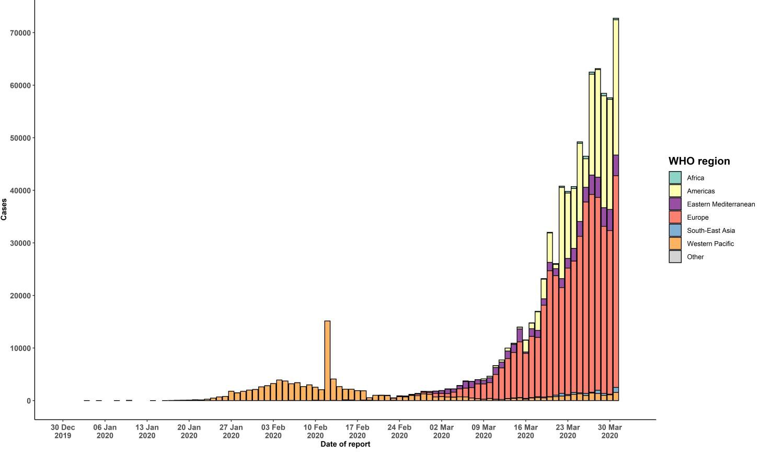

STRATEGIC OBJECTIVES

WHO’s strategic objectives for this response are to:

  - Interrupt human-to-human transmission including reducing secondary infections among close contacts and health care workers, preventing transmission amplification events, and preventing further international spread*;
  - Identify, isolate and care for patients early, including providing optimized care for infected patients;
  - Identify and reduce transmission from the animal source;
  - Address crucial unknowns regarding clinical severity, extent of transmission and infection, treatment options, and accelerate the development of diagnostics, therapeutics and vaccines;
  - Communicate critical risk and event information to all communities and counter misinformation;
  - Minimize social and economic impact through multisectoral partnerships.

*This can be achieved through a combination of public health measures, such as rapid identification, diagnosis and management of the cases, identification and follow up of the contacts, infection prevention and control in health care settings, implementation of health measures for travelers, awareness-raising in the population and risk communication.
PREPAREDNESS AND RESPONSE
- To view all technical guidance documents regarding COVID-19, please go to this webpage.
- WHO has developed interim guidance for laboratory diagnosis, advice on the use of masks during home care and in health care settings in the context of the novel coronavirus (2019-nCoV) outbreak, clinical management, infection prevention and control in health care settings, home care for patients with suspected novel coronavirus, risk communication and community engagement and Global Surveillance for human infection with novel coronavirus (2019-nCoV).
- WHO is working closely with International Air Transport Association (IATA) and have jointly developed a guidance document to provide advice to cabin crew and airport workers, based on country queries. The guidance can be found on the IATA webpage.
- WHO has been in regular and direct contact with Member States where cases have been reported. WHO is also informing other countries about the situation and providing support as requested.
- WHO is working with its networks of researchers and other experts to coordinate global work on surveillance, epidemiology, mathematical modelling, diagnostics and virology, clinical care and treatment, infection prevention and control, and risk communication. WHO has issued interim guidance for countries, which are updated regularly.
- WHO has prepared a disease commodity package that includes an essential list of biomedical equipment, medicines and supplies necessary to care for patients with 2019-nCoV.
- WHO has provided recommendations to reduce risk of transmission from animals to humans.
- WHO has published an updated advice for international traffic in relation to the outbreak of the novel coronavirus 2019-nCoV.
- WHO has activated the R&D blueprint to accelerate diagnostics, vaccines, and therapeutics.
- OpenWHO is an interactive, web-based, knowledge-transfer platform offering online courses to improve the response to health emergencies. COVID-19 courses can be found here and courses in additional national languages here. Specifically, WHO has developed online courses on the following topics:
  - A general introduction to emerging respiratory viruses, including novel coronaviruses (available in Arabic, Chinese, English, French, Russian, Spanish, Hindi, Indian Sign Language, Persian, Portuguese, Serbian and Turkish);
  - Clinical care for Severe Acute Respiratory Infections (available in English, French, Russian, Indonesian and Vietnamese);
  - Health and safety briefing for respiratory diseases - ePROTECT (available in Chinese, English, French, Russian, Spanish, Indonesian and Portuguese);
  - Infection Prevention and Control for Novel Coronavirus (COVID-19) (available in Chinese, English, French,
Russian, Spanish, Indonesian, Italian, Japanese, Portuguese and Serbian); and
  - COVID-19 Operational Planning Guidelines and COVID-19 Partners Platform to support country preparedness and response (available in English and coming soon in additional languages).
- WHO is providing guidance on early investigations, which are critical in an outbreak of a new virus. The data collected from the protocols can be used to refine recommendations for surveillance and case definitions, to characterize the key epidemiological transmission features of COVID-19, help understand spread, severity, spectrum of disease, impact on the community and to inform operational models for implementation of countermeasures such as case isolation, contact tracing and isolation. Several protocols are available here. One such protocol is for the investigation of early COVID-19 cases and contacts (the “First Few X (FFX) Cases and contact investigation protocol for 2019-novel coronavirus (2019-nCoV) infection”). The protocol is designed to gain an early understanding of the key clinical, epidemiological and virological characteristics of the first cases of COVID-19 infection detected in any individual country, to inform the development and updating of public health guidance to manage cases and reduce the potential spread and impact of infection.
RECOMMENDATIONS AND ADVICE FOR THE PUBLIC

If you are not in an area where COVID-19 is spreading or have not travelled from an area where COVID-19 is spreading or have not been in contact with an infected patient, your risk of infection is low. It is understandable that you may feel anxious about the outbreak. Get the facts from reliable sources to help you accurately determine your risks so that you can take reasonable precautions (see Frequently Asked Questions). Seek guidance from WHO, your healthcare provider, your national public health authority or your employer for accurate information on COVID-19 and whether COVID-19 is circulating where you live. It is important to be informed of the situation and take appropriate measures to protect yourself and your family (see Protection measures for everyone).

If you are in an area where there are cases of COVID-19 you need to take the risk of infection seriously. Follow the advice of WHO and guidance issued by national and local health authorities. For most people, COVID-19 infection will cause mild illness however, it can make some people very ill and, in some people, it can be fatal. Older people, and those with pre-existing medical conditions (such as cardiovascular disease, chronic respiratory disease or diabetes) are at risk for severe disease (See Protection measures for persons who are in or have recently visited (past 14 days) areas where COVID-19 is spreading).

CASE DEFINITIONS

WHO periodically updates the Global Surveillance for human infection with coronavirus disease (COVID-19) document which includes case definitions.

For easy reference, case definitions are included below.

Suspect case
- A patient with acute respiratory illness (fever and at least one sign/symptom of respiratory disease, e.g., cough, shortness of breath), AND a history of travel to or residence in a location reporting community transmission of COVID-19 disease during the 14 days prior to symptom onset.
OR
- A patient with any acute respiratory illness AND having been in contact with a confirmed or probable COVID-19 case (see definition of contact) in the last 14 days prior to symptom onset;
OR
- A patient with severe acute respiratory illness (fever and at least one sign/symptom of respiratory disease, e.g., cough, shortness of breath; AND requiring hospitalization) AND in the absence of an alternative diagnosis that fully explains the clinical presentation.

Probable case
- A suspect case for whom testing for the COVID-19 virus is inconclusive.
  - Inconclusive being the result of the test reported by the laboratory.
OR
- A suspect case for whom testing could not be performed for any reason.

Confirmed case
A person with laboratory confirmation of COVID-19 infection, irrespective of clinical signs and symptoms.
- Technical guidance for laboratory testing can be found here.

Definition of contact
A contact is a person who experienced any one of the following exposures during the 2 days before and the 14 days
after the onset of symptoms of a probable or confirmed case:
- Face-to-face contact with a probable or confirmed case within 1 meter and for more than 15 minutes;
- Direct physical contact with a probable or confirmed case;
- Direct care for a patient with probable or confirmed COVID-19 disease without using proper personal protective equipment1; OR
- Other situations as indicated by local risk assessments.

Note: for confirmed asymptomatic cases, the period of contact is measured as the 2 days before through the 14 days
after the date on which the sample was taken which led to confirmation.

1 World Health Organization. Infection prevention and control during health care when COVID-19 is suspected https://www.who.int/publications-detail/infection-prevention-and-control-during-health-care-when-novel-coronavirus-(ncov)- infection-is-suspected-20200125

